HR Analytical Report

Definition:

HR analytics is a methodology that uses statistical tools and techniques to unify and evaluate employees’ quantitative and qualitative data that helps in bringing out meaningful insights to develop better future decision

making.

HR analytics is an experimental approach that uses software and method based on HR metrics to provide reliable and justifiable human capital results impact effectively and efficiently.

HR analytics is a data-driven framework that understands and evaluates the relationship between the workforce

problems and employee’s performance by driving new insights through existing insights.

HR Analytics is HRM innovation enabled by companies to analyze HR data, processes, and human capital statically. for making data-driven decision making and ignoring the process of a gut feeling. This tool helps make better decisions and test the HR department's effectiveness toward business goals. HRIS has provided a way for HR analytics to grow and develop as it includes some limited analytics solutions within its system.

ROLE OF HUMAN RESOURCE ANALYTICS IN HUMAN RESOURCES:

HR analytics plays a significant role in human resources. Using analytical techniques, HR functions can grow faster and have evidence-based decision-making. HR analytics gathers assess previous information, which provides organizations with positive and negative trends. It evaluates the organizational performance against its competitors easily. HR analytics plays a major role in workforce planning, competitive advantage, employee acquisition to employee retention, leveraging data, developing insights and models for the organization, helping in performance management, data manipulation, selecting suitable modelling techniques, and others.

Requirements of HR:

* Total count of the employees, employees’ age, status,
* Employees attrition rate, Gender of the employee.
* Whether Employees are satisfied or not with the job and their work!
* At which age group company should focus on the employees when an employee will not leave the company and stay in the company for a long period of time? Etc to check the HR role is important.

Technical Stack:

* Tableau
  + Worksheets
  + Dashboard

Overview of the Dataset:

Dataset is available in an excel sheet which is given in GitHub account.

For the dataset download the data from the below link:

<https://github.com/AmiTamakuwala/HR_Analytics_Dashboard.git>

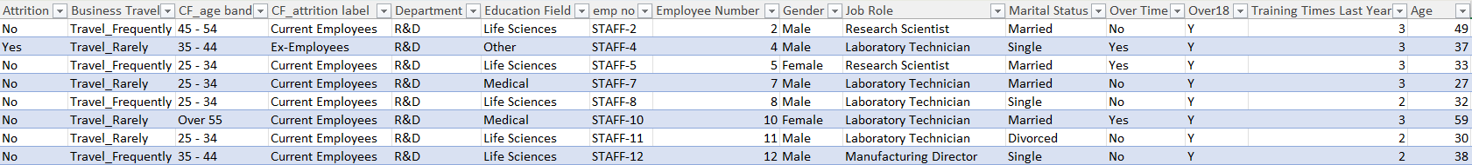

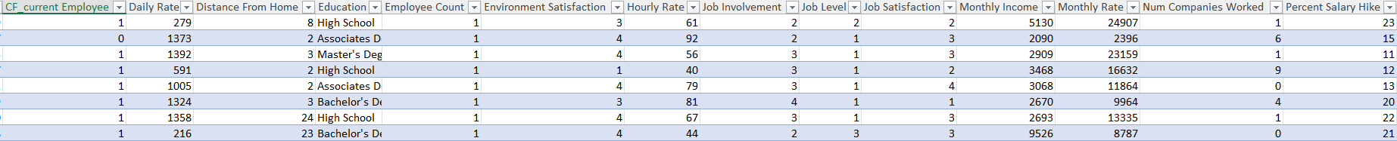

In this dataset there are 39 columns and 1470 rows available.

Exploratory Data Analysis:

* How many employees are working in the company?
* What is the percentage of the attrition rate?
* What is the count of Attrition?
* How many employees are active in the company?
* What is the average age of employees who are working in the company?
* What is the total count of attrition by gender?
* In which department attrition rate is high?
* In which department attrition rate is low?
* What are the ages of employees in the company?
* At which age company should consider whether the employees will work for a long period?
* What is the job satisfaction rate in a different department?
* In which education field wise the attrition rate high?
* What is the attrition rate by gender for different Age Group?

Benefits:

* From this dashboard, HR will find the attrition rate and can find the reason why the employees are leaving the company.
* In which department attrition rate is high and why this situation is happening and how many employees they should hire for better results for the company to give satisfy their customer service?
* Which is more focused on the work in the company according that they should plan their strategies?
* What are the strategies they should make to increase the satisfaction rate of the employee?

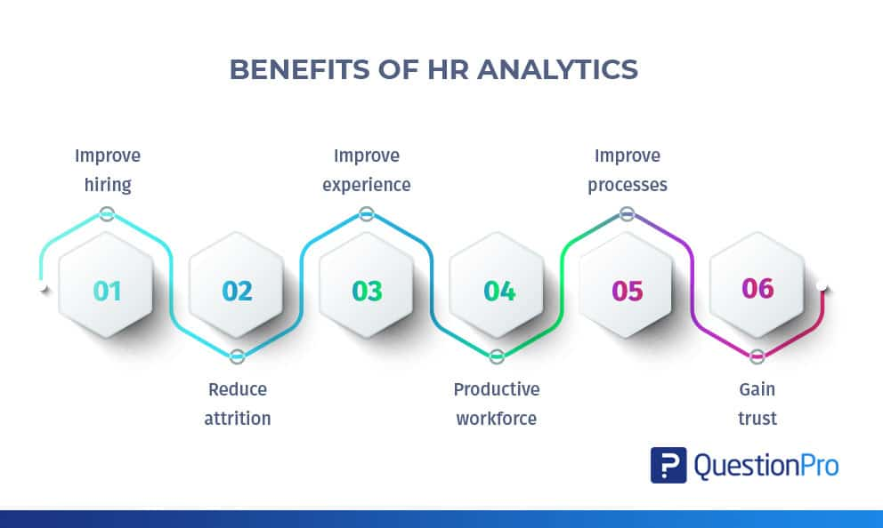

Key Takeaways:

* Get knowledge of different charts like donut charts of the attrition rate by gender for different age groups, pie charts, bar chart, the average rate of attrition & Age.
* Filter of different educational filed.
* Define attrition by gender using the lollypop chart.
* Correlation for the job satisfaction rating with the different job roles.
* Understand the requirement of HR based on the data.
* Get knowledge of some calculation fields using if, else, sum, etc.
* Developed analytical and visualization thinking.
* Developed the knowledge of choosing the type of chart for visualization.
* Learned some beautiful Dashboarding techniques where to upload the background from the .pptx file and convert into a .png file for the tableau dashboard use.
* So many different charts, copy some images, activate some filters related to another filters and chart which will boost our productivity.